

**MEMORANDUM OF UNDERSTANDING**

This is a document validating an agreement between **MR. OGABOR JOHN AND MR. BLESSING AKAH** for the collaborative of 20% interest over a sum of **FIVE HUNDRED THOUSAND NAIRA ONLY (N500,000) paid on the 15th of May, 2020.**

There is a binding agreement to pay the initial capital invested, alongside the interest, **SIX HUNDRED THOUSAND NAIRA ONLY (N600,000) on the 15th of June, 2020** by **MR. OGABOR JOHN TO MR. BLESSING AKAH.**

Attached with this document is an evidence of payment by **MR. BLESSING AKAH.**

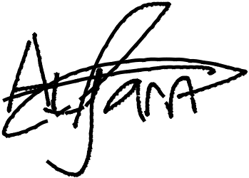

_________________________

_~~__~~_____~~___~~_~~_~~___________



**MR. BLESSING AKAH**

**MR. OGABOR JOHN**

***(CEO, JOHN INVESTMENTS)***